**Speed Alert**

**Project Goal and Objectives:**

Motivation: People on the move sometimes do not care about the speed limit of the road they go. Even after continuous policing and reprimands by the cops or the family members some do the same and cross the speed limit which is dangerous to them and even to others. Our idea is to track a family member such that he/she does not cross the speed limit.

Significance: As number of people die due to accidents every year due to crossing speed limits and get tickets on them by the police. Our aim was to minimize the accidents and the tickets which can only be done using continuous tracking of the speed of the person in the car.

Objectives: The objective of the application is to continuously track the speed of the vehicle and send an alert as soon as the person crosses the speed limit set by the family member. As the family member receives an alert he uses the sensortag for making the basic functions like sending a text message to the person, making a call etc.

System Features:

The main system features include:

* Tracking the speed continuously.
* Sending an alert whenever the speed limit is crossed.
* Presetting the speed limit.
* Making Calls Using Sensor tag.
* Sending a text message using sensor tag.

**Activity Recognition Scenario and Data Collection:**

Devices/Sensors:

The devices we have planned to use are the sensor tag, android smartphone. Sensor tag is used to store the gestures for making calls and text messages. The smartphone is used to calculate the speed of the vehicle.

Data Collection and Preparation:

When a gesture is used to make a call to the person who has crossed the speed limit. First, the system is to be trained for gestures. Then, a gesture is assigned to a contact. The system is trained using the data collection initially using the testing data.

Motion/Activity Model:

Analytics Tasks:

The application at the vehicle runs continuously to track the speed and at the same time detects if the speed of the vehicle crosses the limit set by the family member. The application at the family member receives the alert. Gets ready for the recognition of the gesture which is trained previously using the testing data when the application is first opened.

**Design and Implementation of Mobile Client:**

Two separate User interfaces are to be developed. One is on the vehicle side which is simple and has just one start button which when presses starts the tracking of the speed. Another interface with the family member which has the drop down button to select the contacts from the phone. Buttons to save the gesture for each contact to make a call or send a text message. Applications are developed using Android SDK.

**Design and Implementation of Big Data Analytics:**

All the data received from sensor tag is uploaded to HBase and processed using REST services developed and hosted on cloud.

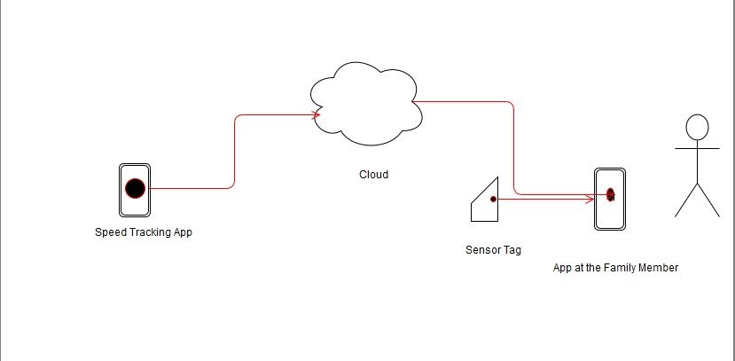

Data Model:

All the accelerometer values are recorded from the sensor tag to the phone. From the phone the values are uploaded to the cloud (Hbase) for the processing and the gesture recognition. The data model we used is:

Accelerometer values:

|  |  |  |
| --- | --- | --- |
| X | Y | Z |
|  |  |  |
|  |  |  |
|  |  |  |
|  |  |  |

In the hbase three column families are used x,y,z.